34.34: a) 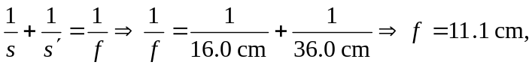converging.
b) 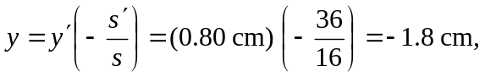so the image is inverted.
c)

